**NAME** / NOUR ELDIN MAHMOUD ABD ELGHAFAR

**B.N** / 1000

**TOPIC** / Artificial Intelligence

What is Artificial Intelligence?

Artificial intelligence (AI) is a broad branch of computer science responsible for building intelligent machines capable of performing tasks that require human ingenuity. AI is an interactive science that has many ways, but advances in machine learning and deep learning are causing paradigm shifts in almost every aspect of the technology sector.

WHY research AI is safety ?

In the near future, the goal of maintaining the impact of AI on a mutually beneficial society is stimulating research in many areas, from economic and legal to technical topics such as authentication, authenticity, security and control. While it may not be just a minor problem when your laptop crashes or is hacked, it becomes more important for the AI ​​system to do what it intends to do when controlling your car, your plane, your pacemaker, your automatic trading system or your power grid. Another short-term challenge is to protect the destructive arm race from self-destructive mortals.

In the long run, the important question is what will happen if the demand for robust AI is successful and the AI ​​system becomes better than humans in all cognitive functions. As pointed out by IJ. Well in 1965, designing intelligent AI systems in itself is a work of common sense. Such a system that may be responsible for self-renewal, has caused an explosion of creativity which leaves the human genius shrunk. By inventing a revolutionary new technology, such ingenuity can help us eliminate war, disease, and poverty, so the creation of a robust AI can be the biggest event in human history. Some experts have expressed concern, however, that it may also be the last, unless we learn to align AI's objectives with our own before it can be smarter.

There are some who doubt that strong AI will ever be achieved, and others who argue that the creation of superintelligent AI is guaranteed to be profitable. At FLI we recognize both of these opportunities, but we also recognize the power of an artificial intelligence system that can intentionally or unintentionally cause great harm. We believe that research today will help us better prepare ourselves and prevent potential negative consequences in the future, thus enjoying the benefits of AI while avoiding pitfalls.

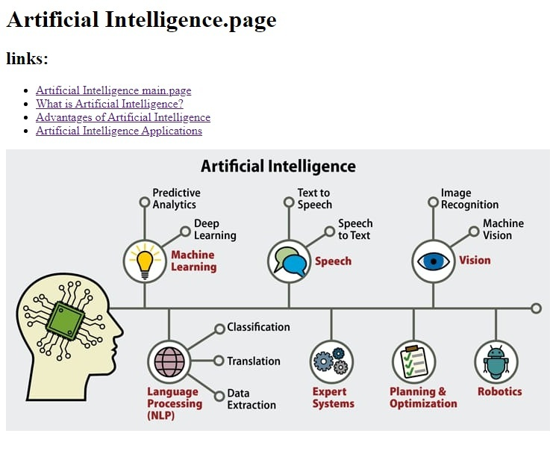

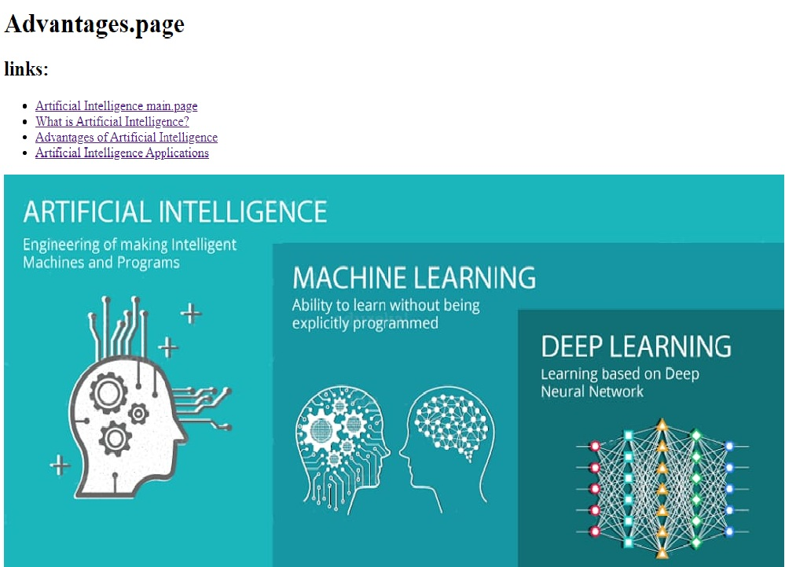

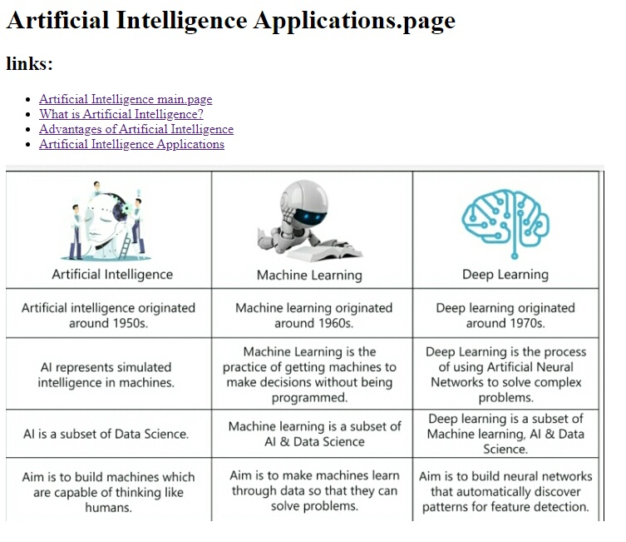

**Artificial Intelligence Applications.page**

**links:**

* Artificial Intelligence main.page
* What is Artificial Intelligence?
* Advantages of Artificial Intelligence
* Artificial Intelligence Applications

**SCURCE CODE :**

